REPORT
01 | Date of activity | 24/07/2025
02 | Attendance | 46
03 | Occasion of activity | Guest lecture on the topic,“Bridging Science and Safety: The Role of Clinical Research in Drug Development”, on 24th July 2025”.
04. | Objective | To provide guidance on career opportunities in Clinical Research and preparation for the same.
05 | Name of the Speaker | Mr. Tanmay D. Gawde, (Advanced Clinical Data Manager,  Aixial) Pune.
06 | Summary of lecture:  Indrayani Vidya Mandir’s Krishnarao Bhegade Institute of Pharmaceutical Education and Research, organized a seminar on the topic,“Bridging Science and Safety: The Role of Clinical Research in Drug Development”, on 24th July 2025”. The guest speaker was heartily welcomed by Mr. Shyam S. Awate. Felicitation and introduction of the guest was done by Principal, IVM’s KBIPER, Pune.  Tanmay sir gave details on basics of clinical research, and phases of clinical trials. He gave the knowledge of whole pharma IT field and various positions and roles which our students can perform in this industry. He keenly answered all the queries of students regarding responsibilities of pharma people in different domains. Also the hierarchy, salary scale and criteria for promotion were discussed.  He gave information about his course called,” The Clinical Pyxida”, in which he and his team are going to deliver a course on clinical research covering 12 domains. The course would be given at a very nominal fee compared to the other classes in this field.  The vote of thanks was given by Ms. P. A. Panmand.
07 | Activity co-coordinator | Mr. Shyam. S. Awate, (TPO), Ms. P. A. Panmand (Coordinator).

Mr. S.S.Awate Dr. Yogesh B. Zambare Dr. Sanjay R. Arote
TPO IQAC Head Principal

Geotag photos of guest lecture
Mr. Tanmay Gawade delivering the information | Students and staff engrossed in the session
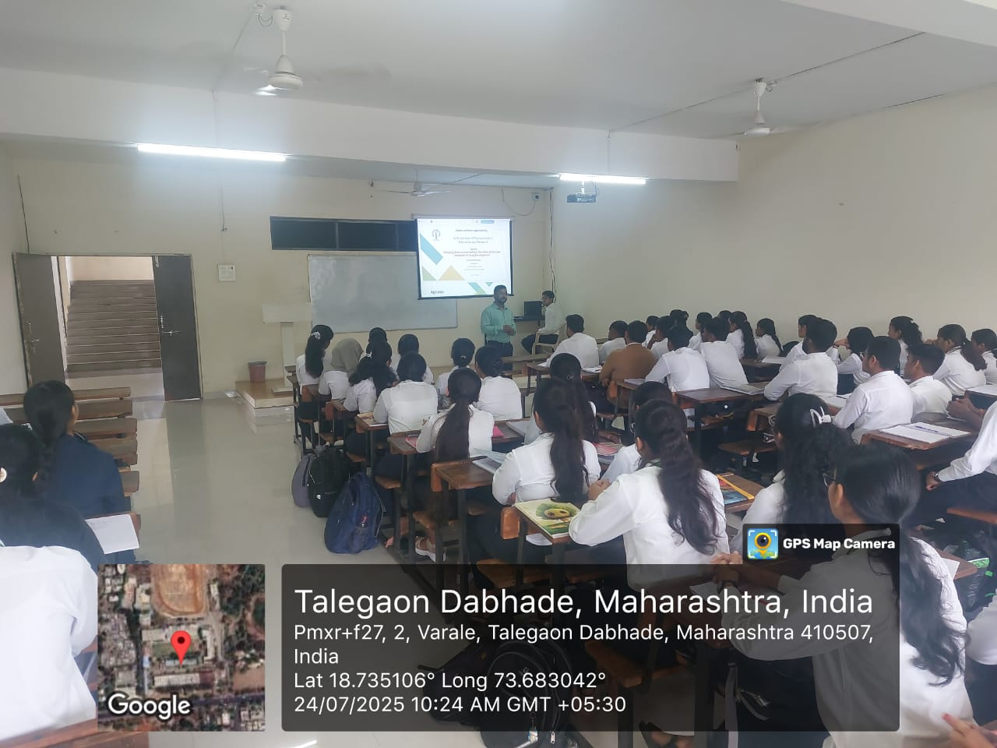 | 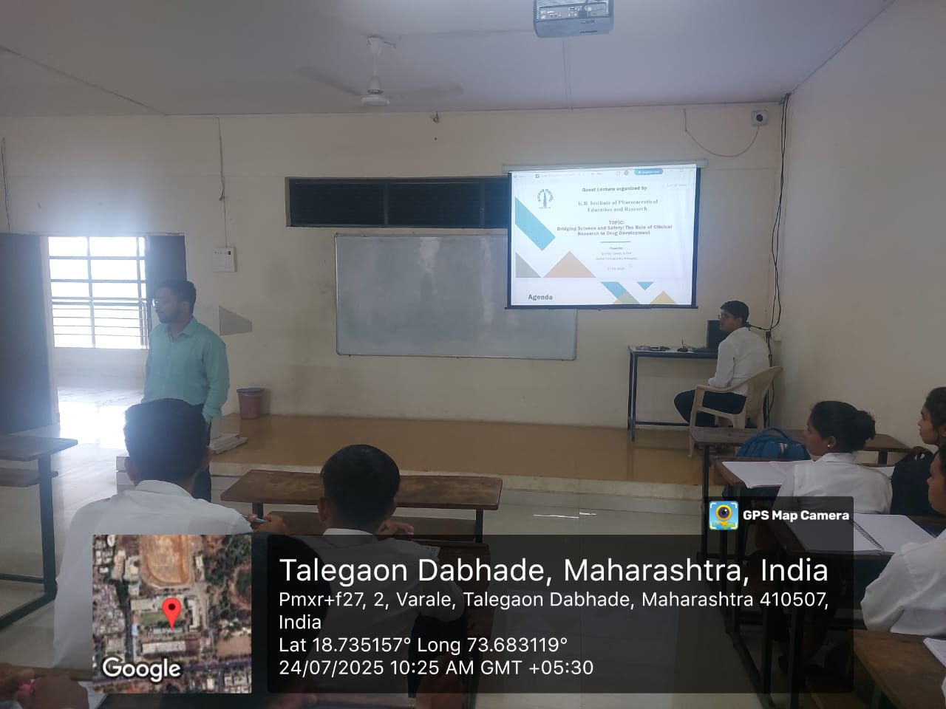
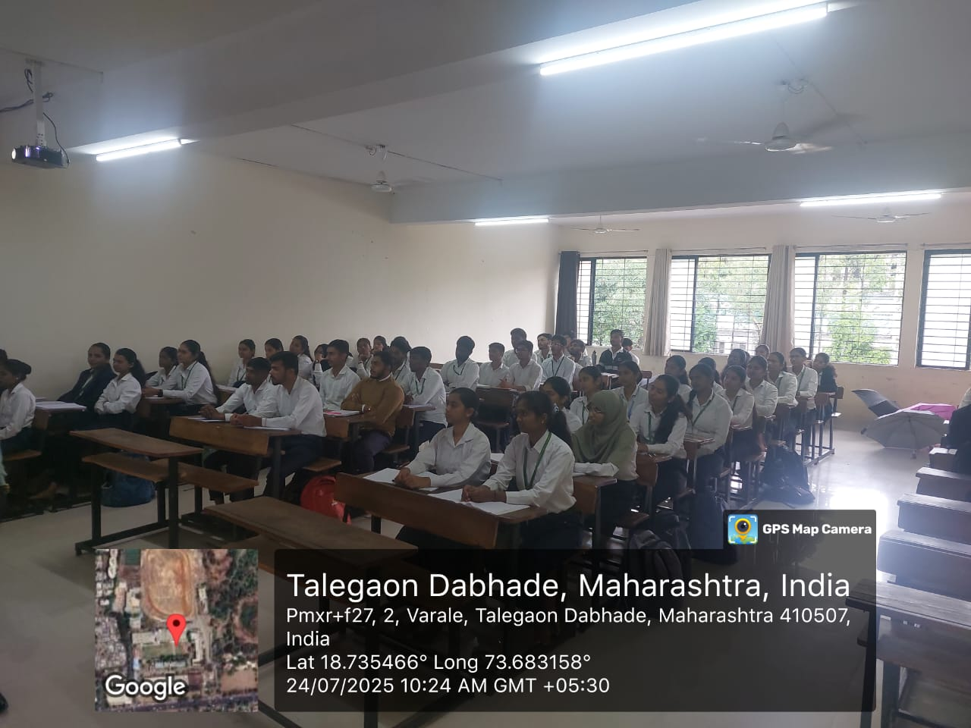 | 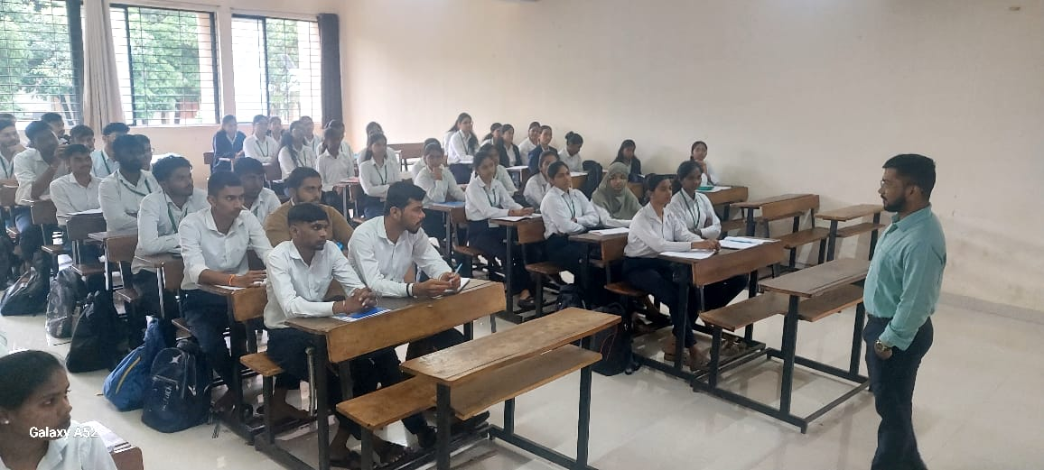

Mr. S.S.Awate Dr. Yogesh B. Zambare Dr. Sanjay R. Arote
TPO IQAC Head Principal

